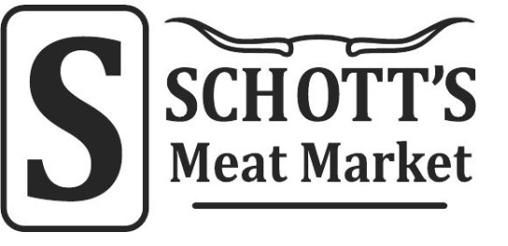

Helotes Alamo Ranch
12952 Bandera Rd, Ste 101 12227 Culebra Rd
Helotes, TX 78023 San Antonio, TX 78253
210-695-5411 210-376-0774

We are NOT associated with Schott Country Store/Meat Market/Deer Processing

Prices Effective September 1, 2024
(Processing fee includes: boning, steak cutting,
tenderizing, grinding & vacuum packaging)

Processing Fee:
Quartered Animals 1.10/lb
Mexican Chorizo | 3.15/lb
Pan Sausage | 3.15/lb
Link Sausage | 3.60/lb
Smoked Sausage | 3.80/lb
Dry Sausage (raw weight) | 4.40/lb
Jerky (raw weight) | 6.25/lb
Snack Sticks (raw weight) | 5.25/lb
Bacon Wrapped Chop steaks | 3.55/lb
Jalapeno or Chili Petine added | .30/lb
Cheese added | .50/lb
Salami | 3.75/lb
Salami (Jalapeno & Cheese) | 4.50/lb
Using Special Recipes | .40/lb
Slicing for Jerky | 2.50/lb
Stuffing sausage & packing (you grind & season) | 1.50/lb
Grinding & packaging hamburger | .75/lb
Beef trim added to hamburger | 2.00/lb
Bacon Wrapped Backstraps | .50/ea
Marinating Steaks | 2.00/lb
Cutting Stew | 1.00/lb
Stuffed Back strap | 4.50/lb

